**Supply List for Mr. Frederick’s Courses**



A charged laptop

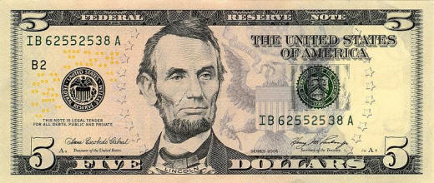

$5.00